Basic Bash shell Scripts

1. Output to screen
#!/bin/bash/
#Simple output Script
Echo ‘Hello world!’

Created vi helloworld.bash script and inserted text echo ‘Hello World!’ into the file.
Used command ll, to list the file names and could see the file that is created.
By using the command chmod 755 helloworld.bash removed write permissions to all others except owner.
Finally, displayed the message “Hello World!” configured in echo using, the command ./helloworld.bash
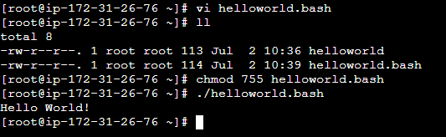
By using, ‘echo’ in the above and below lines of “Hello World!” in the vi file, we get below output:
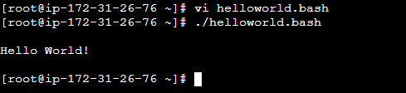

2. Define small tasks
#!/bin/bash
Pwd
Ls
Whoami
Date
Cal
Touch a b c

Created vi commands.bash and inserted small commands pwd, ls, whoami, date, cal, touch a, b, c into the file.
By using the command ll, was able to view the file that is created.
Also by using, ./ commands.bash, executed output which displayed, pwd, list of files, root user, displayed date and calendar. Created zero byte files a, b, c.

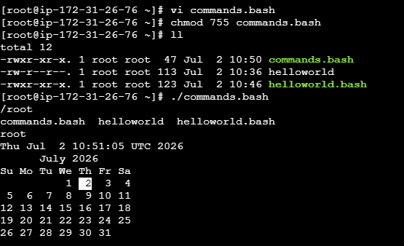

3. #!/bin/bash
Whoami
Echo
Pwd
Echo
Hostname
Echo
Ls -ltr
Echo
With the help of vi commands.bash, created a file and inserted few commands and placed echo between the commands.
By using the command ll, was able to view the file vi commands.bash that is created.
Also by using, ./ commands.bash, executed output which displayed that I am root, Ip address and list of files.

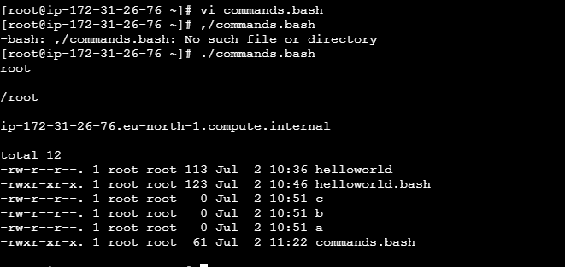

4. Defining Variables:

#!/bin/bash
# Example of defining variables
a=Techie
b=Batch-21
c=’Linux class’
echo "My first name is $a"
echo "My surname is $b"
echo ‘My surname is $c’

Created vi variables.bash file and inserted variables a=Techie, b=Batch-21 and c=Linux class into the file.
Used command ll, to list the file names and could see the file vi variables.bash that is created.
By using the command chmod 755 variables.bash removed write permissions to all others except owner.
Finally, expected output was displayed that was configured in echo using, the command ./variables.bash

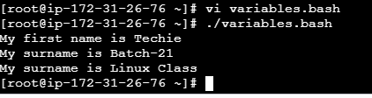

5. Read Input

#!/bin/bash
# Read user input
echo "What is your first name?"
read a
echo
echo "What is your last name?"
read b
echo
echo Hello $a $b

With the help of vi input.bash, created a file then inserted few lines and variables to read and placed echo between the lines.
By using the command ll, was able to view the file vi input.bash that is created.
Also by using, ./input.bash command, displayed the output that is expected.

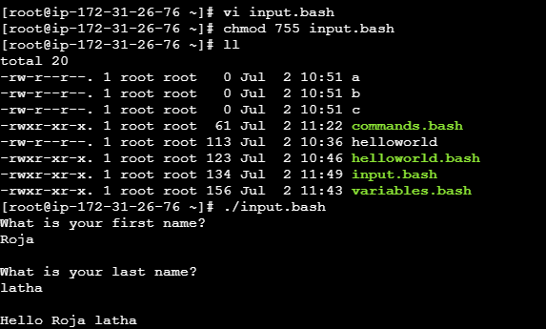

6. Scripts to run commands within

#!/bin/bash
# Script to run commands within
clear
echo "Hello `whoami`"
echo
echo "Today is `date`"
echo
echo "Number of user login: `who | wc -l `"
echo

Created vi commandswithin.bash and inserted lines and placed echo between the lines.
By using the command ll, was able to view the file that is created.
Also by using, ./commandswithin.bash, displayed the expected output.

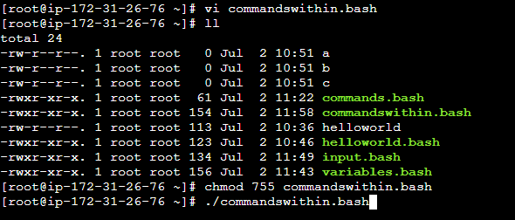

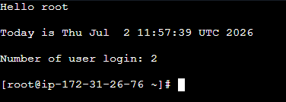

7. Read input and perform a task

#!/bin/bash
# This script will rename a file
echo Enter the file name to be renamed
read oldfilename
echo Enter the new file name
read newfilename
mv $oldfilename $newfilename
echo The file has been renamed as $newfilename

With the help of vi perform.bash, created a file then inserted few lines to read and placed echo between the lines.
By using the command ll, was able to view the file vi perform.bash that is created.
Also by using, ./perform.bash command, was able to read the expected output.

